At present, most of the applications in forest fire identification are directly applied to CNN on the original image set. Due to the complex background and a number of interference in the original image, the result of the training is not so good. Therefore, in this paper, a method is proposed to segment the candidate flame region based on the color feature, and then part of the image is sent to the CNN network for training, which can extract features more specifically and improve the recognition rate of forest fire image effectively. The algorithm flow is shown in [Figure 1](https://journals.sagepub.com/doi/full/10.1177/1748302619887689#fig1-1748302619887689).

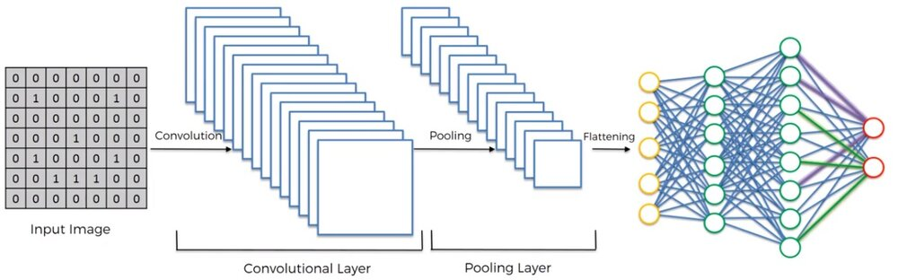

**Figure 1**. Flow chart of forest fire image recognition algorithm based on CNN.[**OPEN IN VIEWER**](https://journals.sagepub.com/doi/full/10.1177/1748302619887689#fig1-1748302619887689)

In the training phase, firstly, the binary image of the suspected flame region is segmented, and the result obtained by performing AND operation between the binary image and the original image is used as a training set, and a label is set for each image. A network model is obtained after training the CNN according to the training set. In the testing phase, similarly, the binary image of the suspected flame region is firstly segmented, and the result obtained by performing AND operation with the original image is used as a testing set. The testing set image is sent to the trained network model to obtain the recognition result.